# Analysis

When giving colors, make sure to see if the color change is **gradual** or **instantaneous**

## Transitional metals

|  |  |  |  |
| --- | --- | --- | --- |
| **Type** | **Ligand** | **Formula** | **Exception** |
| D | OH- |  |  |
| D | OH- (Excess) |  |  |
| D | NH3 |  |  |
| L | NH3 (Excess) |  |  |
| L | Conc. Cl- |  |  |

|  |  |  |  |  |  |  |  |  |  |
| --- | --- | --- | --- | --- | --- | --- | --- | --- | --- |
| **T.M.** | **Oxi.** | **Color** | | | **[D] OH- / NH3** *p.p.* | | **[D] Excess OH-** *sol.* | **[L] Excess NH3***sol.* | **[L] Conc. Cl-** |
| Cu | 2 | B | | | B | |  | B $@ Cu{\left(NH_{3}\right)}_{4}$ | Y |
| Co | 2 | P | | | B | | Br | B |
| Cr | 2, 3, 6 | B | G | Y | G | | G | G |  |
| Ni | 2 | G | | | G | |  | B |
| Zn | 2 | c | | | W | | c | c |
| Fe | 2, 3 | pG | Y | | dG | Br |  |  |
| Mn | 2 | pP | | | W | |

* CuO (Copper II oxide) is black
* ${\left[Cu{\left(NH_{3}\right)}_{2}\right]}^{+}→{\left[Cu{\left(NH_{3}\right)}_{4}\right]}^{2+}$ upon vigorous shaking due to oxidation by O2
* 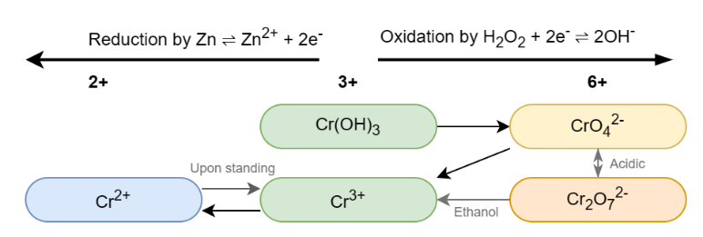Compounds with different transitional metals will result in a **mixture** of individual colors

### Chromium reactions

### Vanadium colors

|  |  |  |  |
| --- | --- | --- | --- |
|  |  |  |  |
| +2 **V2+** | +3  **V3+** | +4  **VO2+** | +5  **VO2+** |

When reducing from VO2+, color changes to green first instead of blue because of the **mixture** **of VO2+ and VO2+**

V2+ is oxidized to V3+ on standing due to oxidation by O2

## Inorganic compounds

|  |  |  |
| --- | --- | --- |
| **Species** | **Observation** | **Hazard & Minimizing risk** |
| NO2(g) | Brown gas | Toxic, fume cupboard |
| Cl2(g) | White fumes | Toxic, fume cupboard |
| Ba2+ | - | Toxic, fume cupboard |
| HCl(g) | Alkaline **B** 🡪 **R** | Toxic, fume cupboard |
| Any acid | - | Corrosive, gloves |
| Benzene | - | Toxic |
| NH3 | litmus paper **R** 🡪 **B** | Toxic, fume cupboard |

### Ammonia NH3

Reagent: HCl(g)

Observation: **White** fumes (NH4Cl ammonium chloride)

### Ammonium NH4+

Reagent: Warm aqueous NaOH

Observation: Gas given off, litmus paper **R** 🡪 **B** (NH3 alkaline)

### Sulfate SO42- / Barium Ba2+

Reagent: Acidified Ba2+

Observation: **White** pp (BaSO4 insoluble in dilute acids)

### Carbonates CO32-

Reagent: Ba2+

Observation: **White** pp (BaCO3 soluble in dilute acids)

Reagent: H+ from HCl / HNO3

Observation: Bubbles (CO2 milky lime water)

Reason: $CO_{3}^{2-}\left(aq\right)+2H^{+}\left(aq\right)→CO_{2}\left(g\right)+H_{2}O(l)$

### Group 7 anions

Reagent: HNO3, AgNO3

Observation: {Cl-, Br-, I-} : {**White**, **Cream**, **Yellow**} pp $→AgX$

***AgCl*** *is soluble in dilute NH3*

Reagent: Conc. H2SO4

Observation: {Cl-, Br-, I-} : {**Misty** HCl, **Brown** Br2, **Purple** I2} fumes

## Organic compounds

### -OH hydroxyl group (-OOH included)

Reagent: PCl5(s)

Observation: **White** fumes (HCl)

*These tests can’t be conducted in the presence of H2O as reagents react with H2O instead*

### -OOH group

Reagent: CO32-

Observation: Bubbles (CO2 milky lime water)

### Aldehydes apart from ketones

Reagent: Fehling’s / Benedict’s reagent

Observation: **B** 🡪 **R** (Cu2O)

### 3° or 1° / 2° Alcohols

Reagent: Acidified Potassium Dichromate K2Cr2O7

Observation: 3° Remains **orange** 1° / 2° 🡪 **green**

Reason: Only 1° / 2° alcohols can be oxidized

### CH3C=O group

Reagent: Warm alkaline sol. I2

Observation: **yellow** p.p. (CHI3)

# Essential knowledge from old chapters

$$Percentage uncertainty=\frac{times read×uncertainty}{value}$$

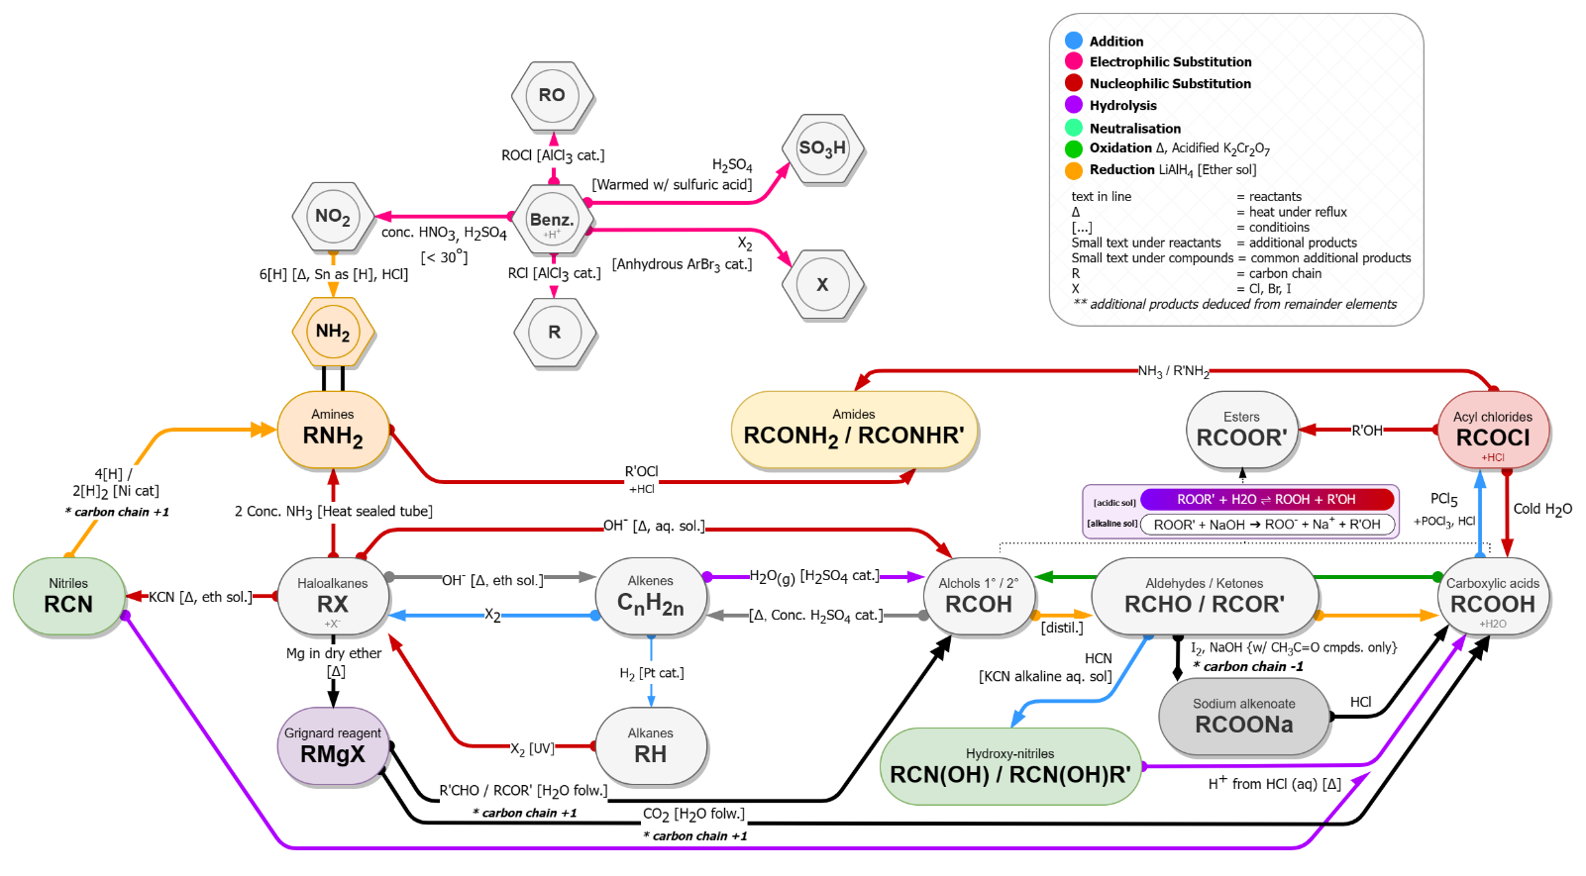

Alkenes $→$ Diols via $KMnO_{4}$ attaching 2 $\text{-}OH$ groups at each end of the $C\text{=}C$ bond

### Preparation of azo compounds

1. Formation of nitrous acid: (5° NaNO2 + dilute HCl: NaNO2 decomposes)
2. Formation of diazonium ion: $ArNH_{2}+HNO_{2}+HCl→ArN^{+}\text{≡}NCl^{-}+2H_{2}O$ (5°: >10° forms phenol, <0° rate slow)
3. Coupling reaction: $ArN^{+}\text{≡}NCl^{-}+ArOH→ArN\text{=}NArOH+HCl$ (Alkaline sol.)

### Determining empirical formula

|  |  |  |
| --- | --- | --- |
| Corrosive | Oxidising | Flammable |
| *Explosive* | *Oxidizing* | *Flammable* |
| Corrosive |  | Toxic |
| *Corrosive* | *Health hazard* | *Toxic* |

1. Find mass of all elements
2. Find mol of all elements
3. Using simplified mol ratio to determine empirical formula

### Optical isomerism

Use polarimeter to distinguish isomers rotating PPL in opposite directions

### Mass spectrometry

* Mass spectrum is consistent with the compound when there’s a peak at Ar
* Mass peak = $\frac{mass}{charge}$
* Peaks at different positions caused by **ions+** of the compound

### NMR Spectroscopy

* Position of peaks are the chemical shifts of corresponding atoms
* n of peaks n of X in diff ChemEnv
* Ratio of (area of) peaks Ratio of amounts of ChemEnv
* Split peaks n of adj. protons

# Common experiments & methods

### Drying agents

Most compounds can be dried with **MgSO4** (anhydrous salt & doesn’t react). Alternatively, use silica gel.

## Find: Enthalpy change of reaction

*Graphical method to find $ΔT$*

*(extrapolation)*

$$ΔH=-\frac{mcΔt}{n} mcΔt=heat energy Q$$

$$m=mass of solvent in g∪cm^{3} c=specific heat capacity$$

$$n=mol of solute$$

1. Measure T / 30s
2. Add solution at 3 min
3. Measure T / 30s for 5 min
4. Plot T-t graph, best fit line
5. Extrapolate and find max temperature change

## To: Titrate

### To: Prepare standard solution

Procedure:

1. Dissolve solid in conical flask with distilled water
2. Pour the solution into volumetric flask with washings
3. Add water up to the mark & shake
4. Indicator in burette
5. Indicator drop by drop at end point
6. Record when color changes
7. Repeat to obtain $±0.2cm^{3}$ titres
8. *Ways to improve accuracy:*
   1. White tile
   2. Swirl close to end point
   3. Rinse conical flask with distilled water

* When to add starch indicator: **Near the end point** as to **avoid solid forming**
* Acidified mixture titrating with KMnO4: If not MnO2 will form

## To: Prepare organic compounds with reflux / distillation

Both setups are **not sealed!**

|  |  |
| --- | --- |
|  |  |
| *Reflux setup – ensures complete oxidation* | *Distillation setup – prevents further oxidation* |

### Common questions

**Prepare solution**

* Cooling when addition: Reaction exothermic, prevent boiling over

**Reflux**

* Use of reflux: Give complete reaction
* Use of condenser: Prevent escape of compounds
* 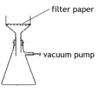Continuous stirring: Reactants do not mix, ensure enough contact

**Separating funnel**

* Observations physical properties: Density comparison, insolubility
* Release pressure: Invert & remove stopper

**Buchner funnel (reduced pressure filtration)**

* Advantages: Greater speed, dries product

## Find: Total order of reaction

Common reactions: $5Br^{-}+BrO_{3}^{-}+6H^{+}→3Br_{2}+3H_{2}O$

* Pouring contents between beakers: To ensure no reactants remain in one breaker
* Use phenol: React with Br2 to delay color change
* $V∝conc.$: Total volume constant
* Use ethanol in mixture: Dissolves reagents (H2O doesn’t) allowing them to mix to increase rate

### Finding order of reactants

$$rate=k{\left[R\right]}^{n}$$

|  |  |  |
| --- | --- | --- |
|  | **Concentration-time graphs ([A]-t)** | **Rate-concentration graphs (1/t-[A])** |
| **0 order** | Straight line | Flat line |
| **1st order** | Half-life unchanged | Straight line through origin |
| **2nd order** | Half-life x2 | 1/t-[A] | 1/t-[A]2 |

## To: Recrystallize

1. Dissolve in min amount of hot solvent $→$ saturated solution
2. Filter solution $→$ cool
3. Filter crystals $→$ wash
4. Dry crystals (oven)

* Use of preheated funnel: Prevent crystallization, remove insoluble impurities
* Use of Buchner funnel: Remove soluble impurities
* Use of desiccator instead of oven: Prevent melting
* How does x lead to crystallization: Product is less soluble in x
* Increased or > 100% yield: Damp crystals

## To: Measure m.p.

* Side-arm heated: Distribute heat evenly
* Mineral oil: Allow points > 100°
* Different results: Different pressure
* Test purity: Measure m.p. & compare with data book values
* Pure sample: Sharp m.p., close to book value
* Impure sample: Unsharp, lower m.p.

## To: Combustion analysis

$${\%m}_{C}=\frac{m_{CO_{2}}×\frac{12}{44}}{m_{T}}$$

$${\%m}_{H}=\frac{m_{H_{2}O}×\frac{2}{18}}{m_{T}}$$

${\%m}_{O}=1-{\%m}_{C}-{\%m}_{H}$

$$mol ratio=\frac{\%m_{C}}{12}:\%m_{H}:\%\frac{m_{O}}{16}$$

## To: Find mol of water of hydrated compound

1. Measure mass of sample
2. Heat sample in crucible until mass constant
3. Difference in mass

## Miscellaneous methods

* Reducing % uncertainties: Increase measured value by different methods e.g. reducing concentration
* Ensuring full reactions: No production / reactant observations are seen anymore
* Species in collection apparatus: Remove unreacted reactants

## Common Indicators

|  |  |  |  |
| --- | --- | --- | --- |
| ***Indicator*** | ***Acidic*** | ***Initial*** | ***Alkaline*** |
| Methyl orange | **Red** | **Orange** | **Yellow** |
| Phenolphthalein | **Colorless** | | **Pink** |
| Litmus paper | **Red** | **N/A** | **Blue** |
| Universal | **Red** | **Green** | **Blue** |

Initial color: pH of initial solution

End color: pH of final solution